Design patterns-Martim Costa 64901

Interface location: \ganttproject\src\main\java\net\sourceforge\ganttproject\gui\UIFacade

Class location: \ganttproject\src\main\java\net\sourceforge\ganttproject\UIFacadeImpl

This design pattern is a **Façade**. This Façade provides a unified interface between the different managers (like the notification manager, task selection manager, zoom manager, ...) and other classes too. This way is much simpler to use the subsystems that would be a lot more complex without this Façade.

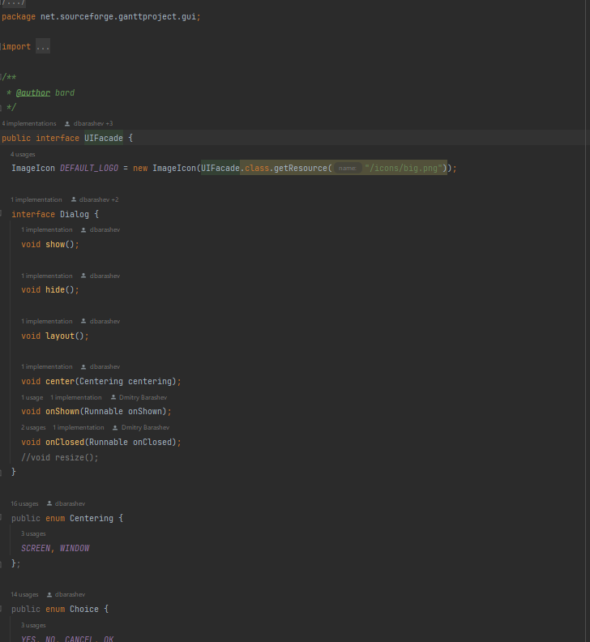

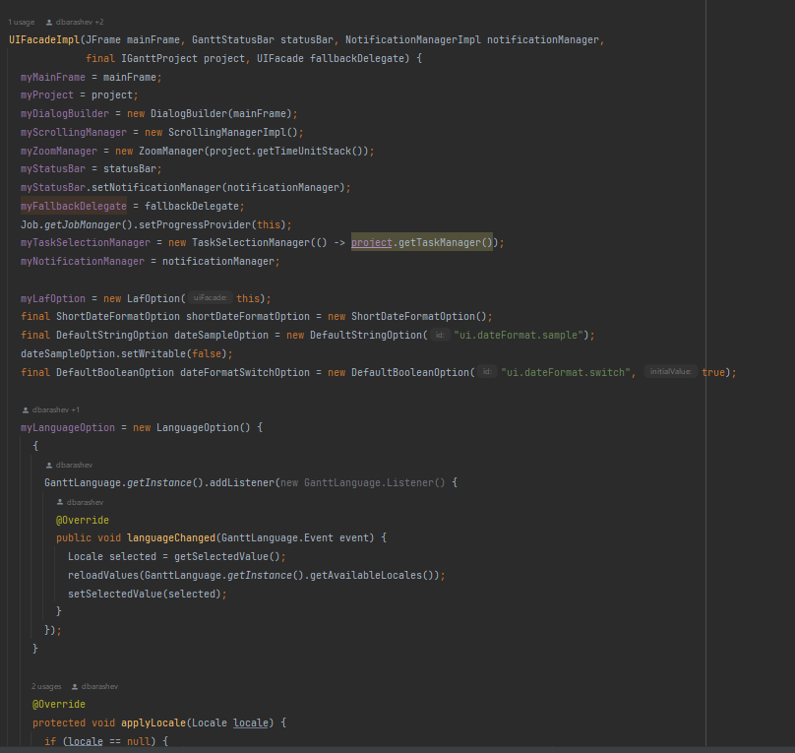

Location: \ganttproject\src\main\java\net\sourceforge\ganttproject\document\ProxyDocument

This design pattern is a **Proxy** (as the name of the class suggest). It performs the same tasks as the “original” class but in this cased is used to not access directly to a document (it has a function called “getRealDocument” that will redirect to the “original” document, for example it is used in the storage of the documents).

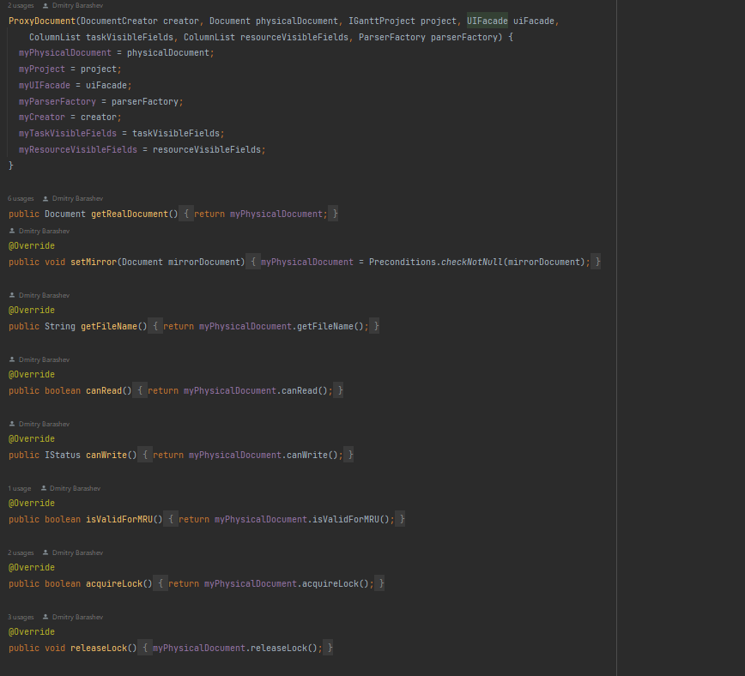

Location: \ganttproject\src\main\java\net\sourceforge\ganttproject\gui\GattLookAndFeels

This design pattern is a **Singleton**. This way the class ensures no other instance is created, by intercepting requests to create new objects and provides the sole way to access the instance. It has a protected constructor, and it has the public method that instantiates the class “if” it is not already instantiated.

